GUVI ASSIGNMENT

Create a database worker that should contain **first name, last name email, department, salary, Join Date** with 50 employees.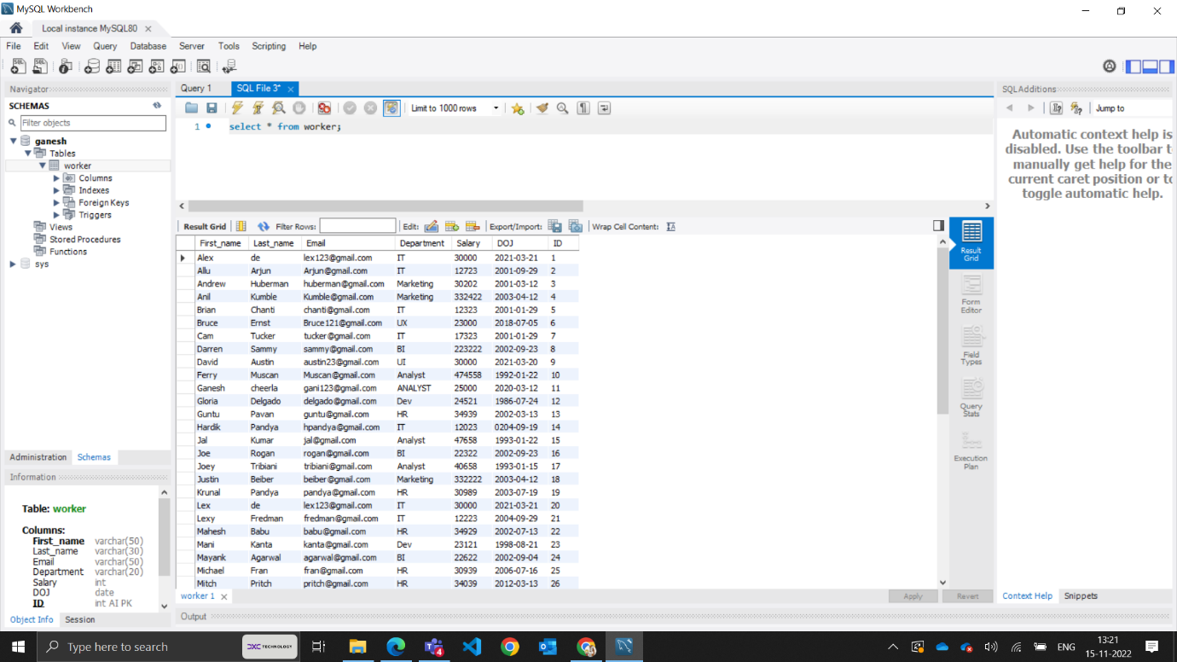

**TASK-1**

1.Write an SQL query to fetch “FIRST_NAME” from the Worker table using the alias name as <WORKER_NAME>.

ANS : select First_name as worker_name from worker;

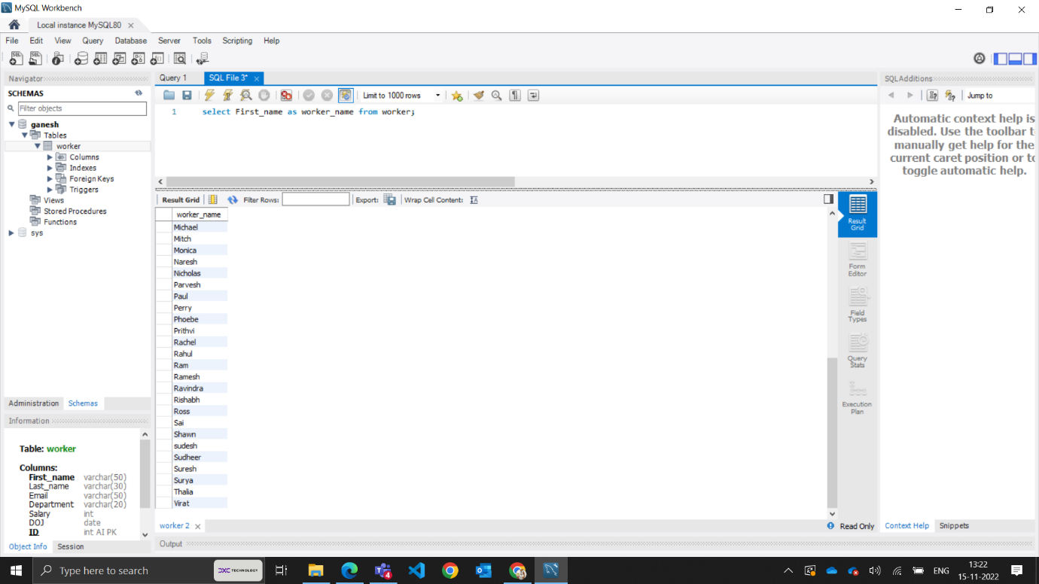

2.Write an SQL query to fetch unique values of DEPARTMENT from the Worker table.

ANS : SELECT DISTINCT Department from worker;

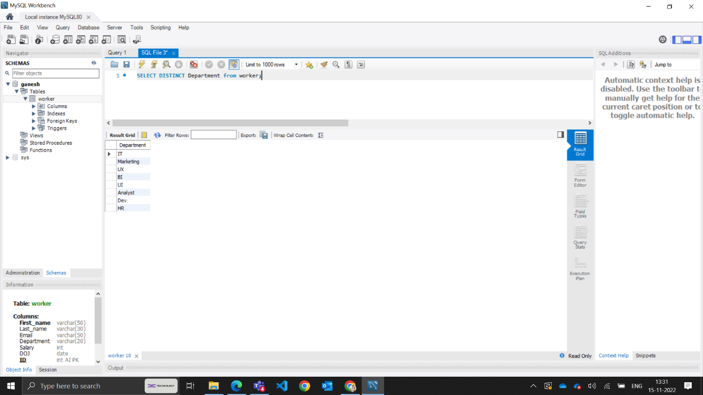

3. Write an SQL query to show the last 5 records from a table.

ANS : (select * from worker order by ID desc limit 5) order by ID asc;

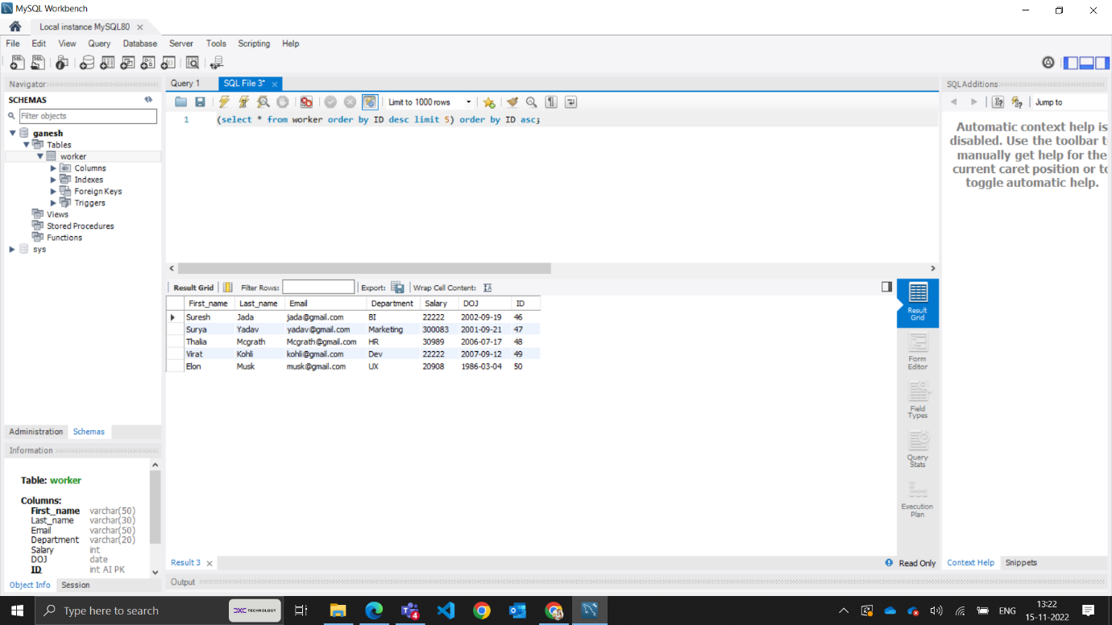

**TASK-2**

1. Write an SQL query to print the first three characters of FIRST_NAME from Worker.

ANS : SELECT SUBSTRING(First_name,1,3) FROM worker;

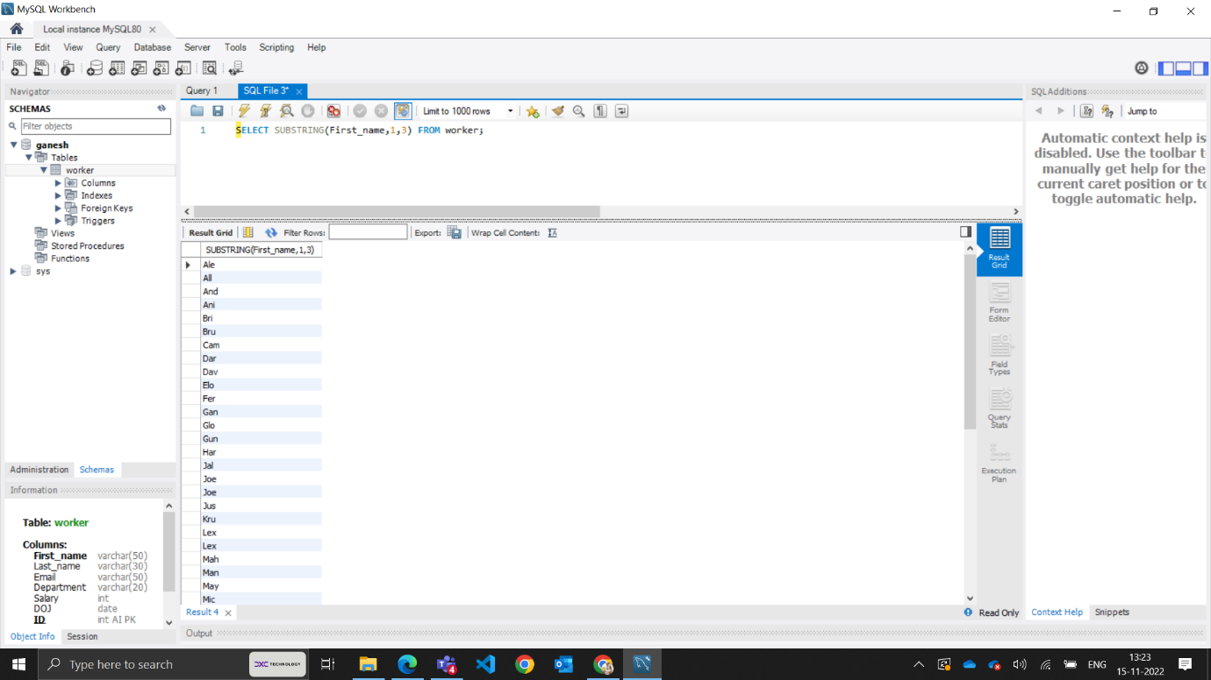

2. Write an SQL query to find the position of the alphabet (‘a’) in the first name.

ANS : Select INSTR(FIRST_NAME, BINARY 'a') from Worker

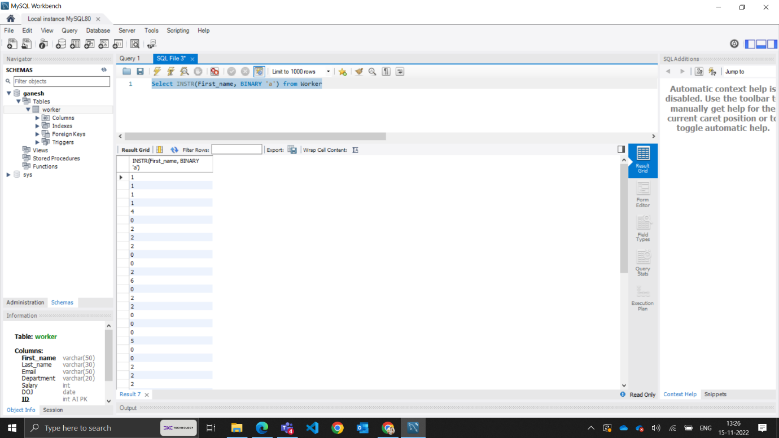

3. Write an SQL query to print the name of employees who have the highest salary in each department.

ANS :SELECT Department, MAX(salary) FROM worker GROUP BY Department;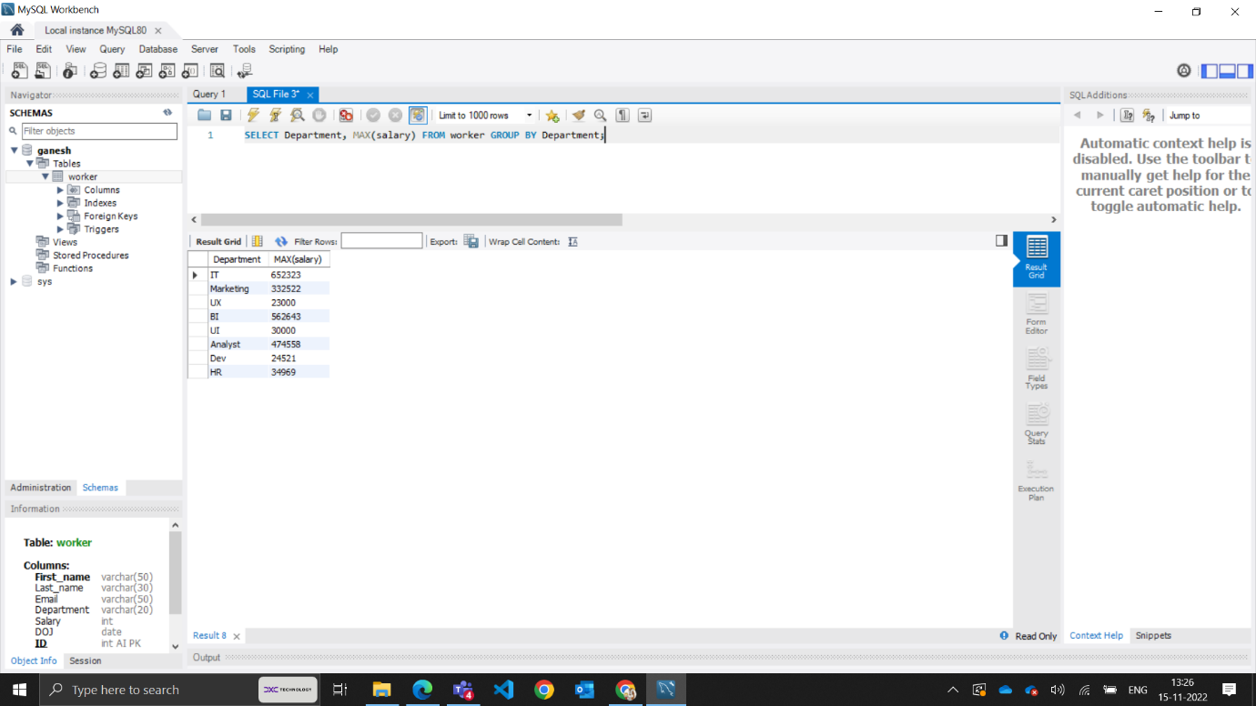

**TASK-3**

1.Write an SQL query to print the FIRST_NAME from the Worker table after removing white spaces from the right side.

ANS : Select RTRIM(First_name) from worker;

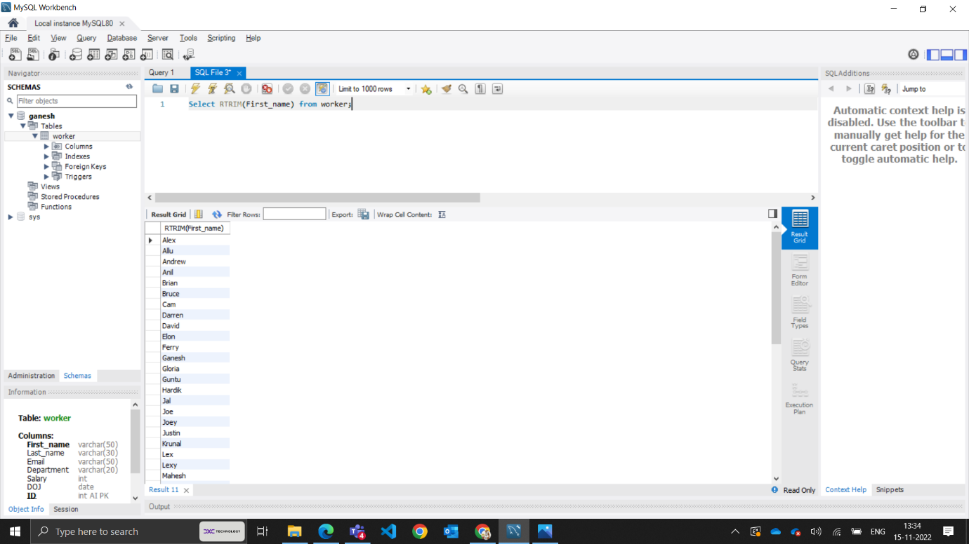

2.Write an SQL query that fetches the unique values of DEPARTMENT from the Worker table and prints its length

ANS : SELECT DISTINCT (Department), length(Department) FROM worker;

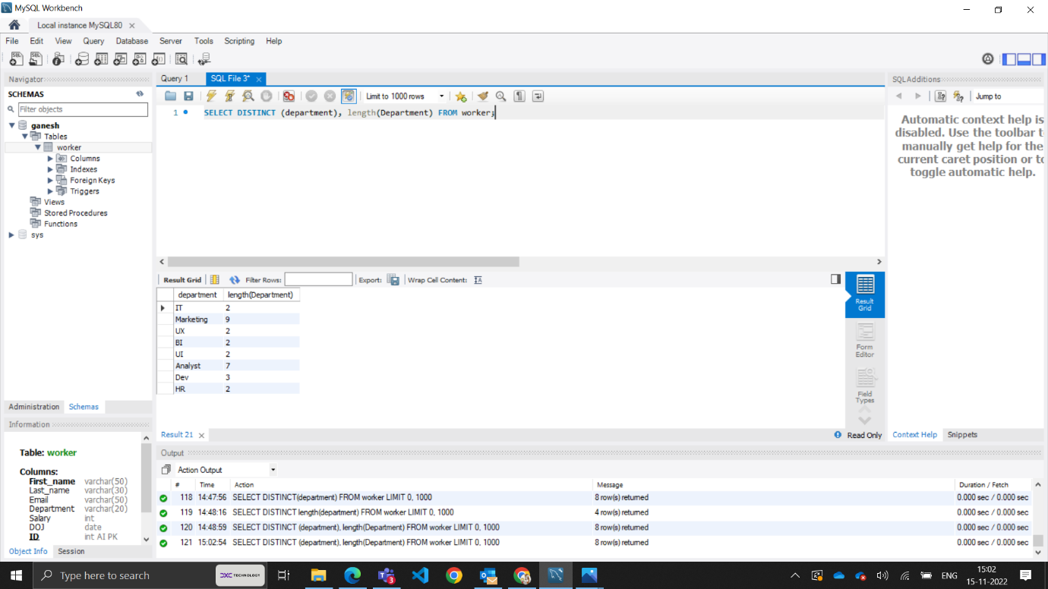

**3.** Write an SQL query to fetch nth max salaries from a table.

ANS : SELECT Salary FROM worker ORDER BY Salary DESC Limit 0,1

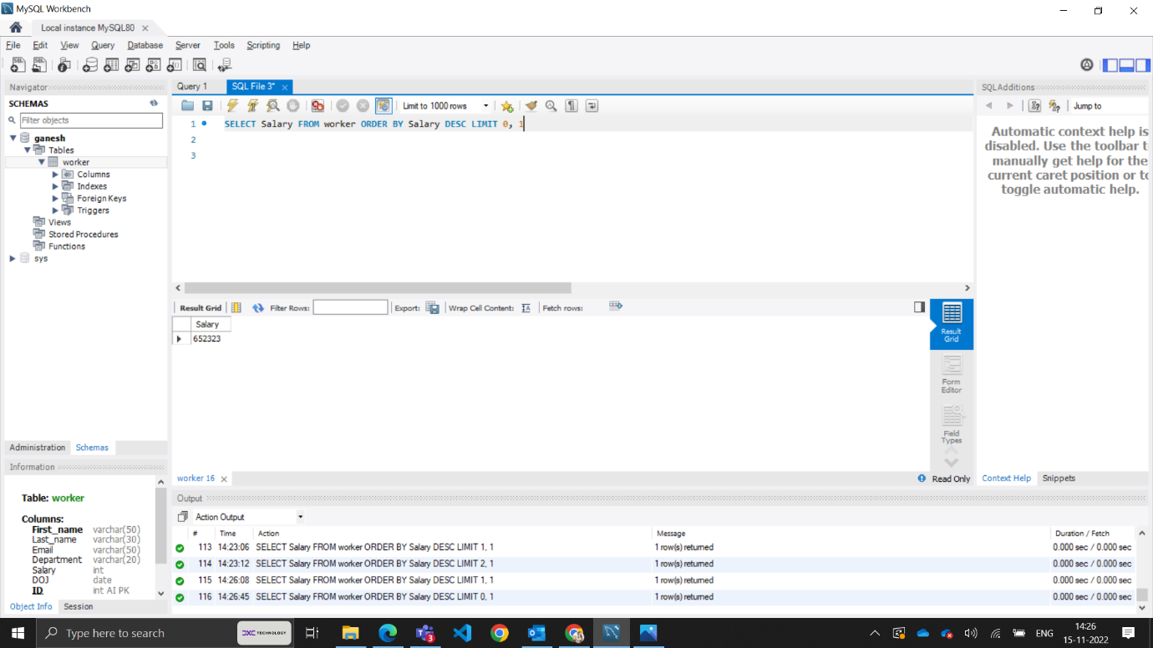

**TASK-4**

1.Write an SQL query to print the FIRST_NAME from the Worker table after replacing ‘a’ with ‘A’.

ANS : SELECT REPLACE (First_name, ‘a’,’A’) FROM worker;

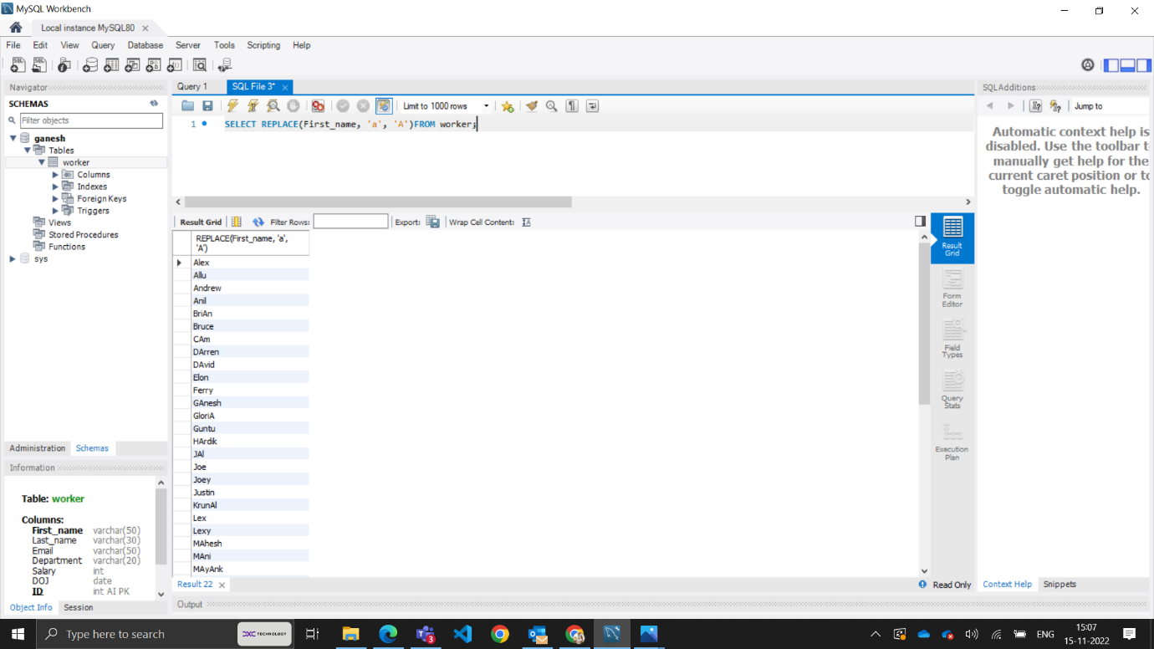

2. Write an SQL query to print all Worker details from the Worker table order FIRST_NAME Ascending and DEPARTMENT Descending.

ANS : SELECT * FROM worker ORDER BY First_name ASC, Department DESC;

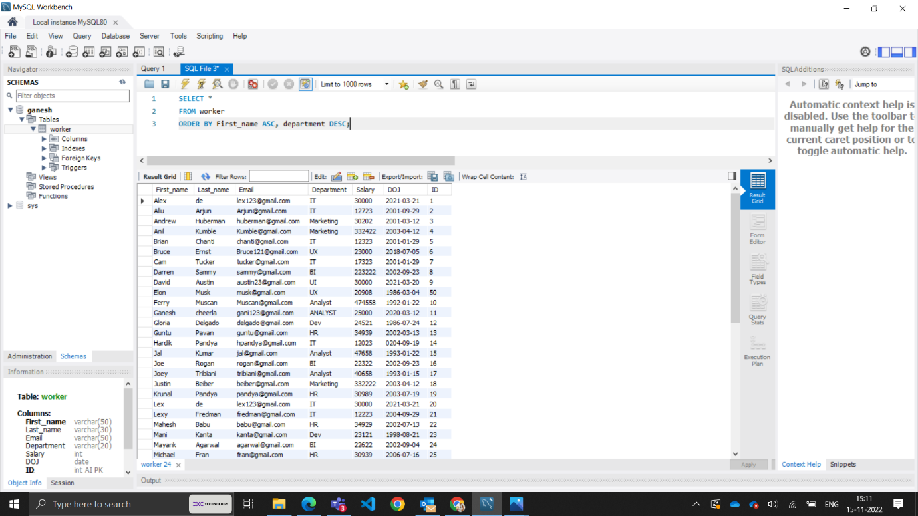

3. Write an SQL query to fetch the names of workers who earn the highest salary

ANS : SELECT First_name,salary from worker where salary = (SELECT max(Salary) from worker);

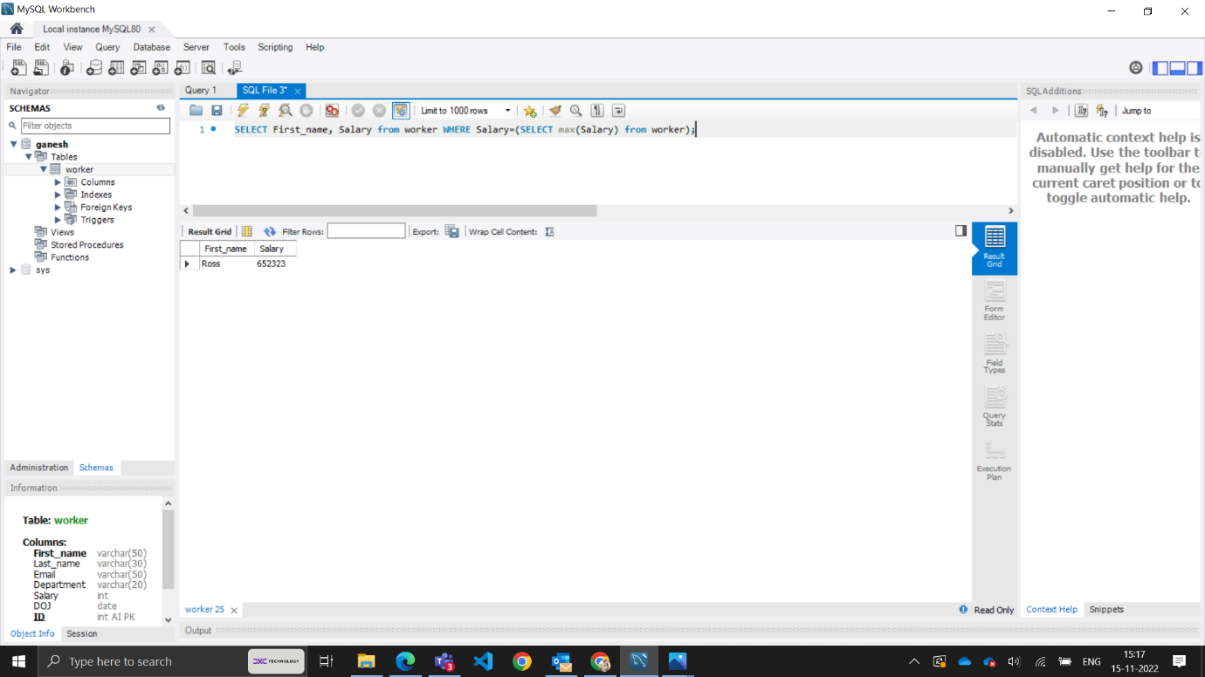

**TASK-5**

1.Write an SQL query to print details of workers excluding first names, “Ramesh” and “Santhosh” from the Worker table.

ANS : SELECT * FROM worker WHERE First_name NOT IN (“RAMESH”,”SANTOSH”);

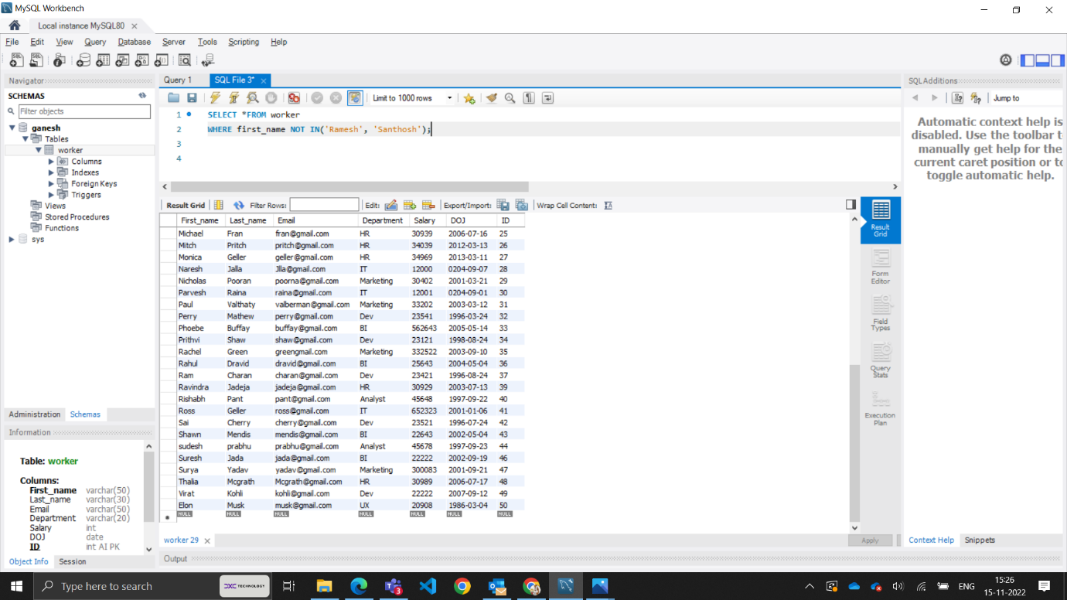

2. Write an SQL query to print details of the Workers whose FIRST_NAME ends with ‘h’ and contains six alphabets.

ANS : SELECT * FROM worker WHERE First_name like ‘_____h’;

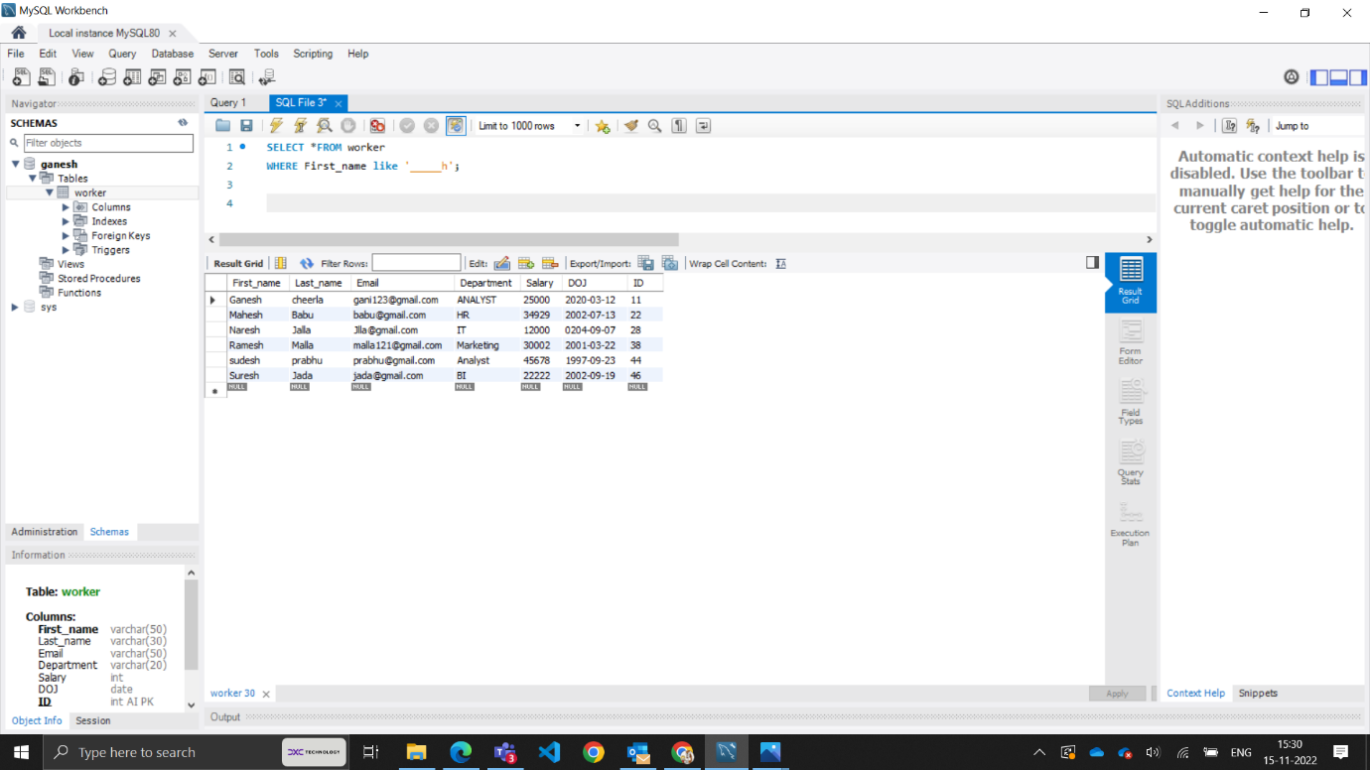

3. Write a query to validate Email of Employee (email should have first name last name and guvi.com example (first name=Kamal last name= raja and the mail id should be [kamalraja@guvi.com](mailto:kamalraja@guvi.com)).

ANS : Select * from worker where (First_name ="Allu" AND Last_name = "Arjun") AND

(Email REGEXP '^[A-Z0-9_%-]+[A-Z0-9_%-]+@[A-Z0-9.-]+\.[A-Z]{2,4}$')

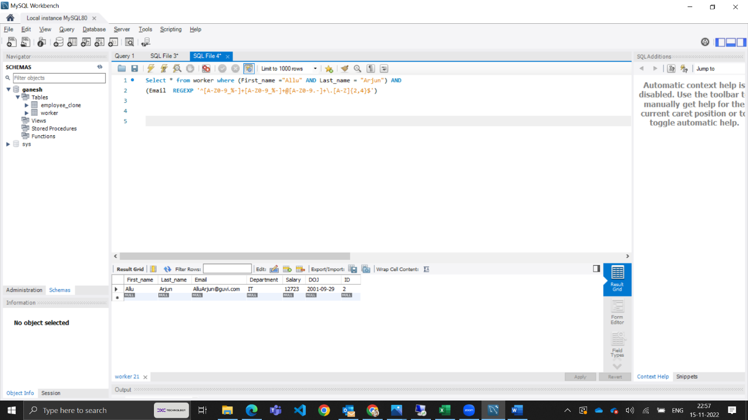

**TASK-6**

**1.** Write an SQL query to print details of the Workers who have joined in March ’2021.

ANS : SELECT * FROM worker WHERE (DOJ) = 2021 and month(DOJ) =3;

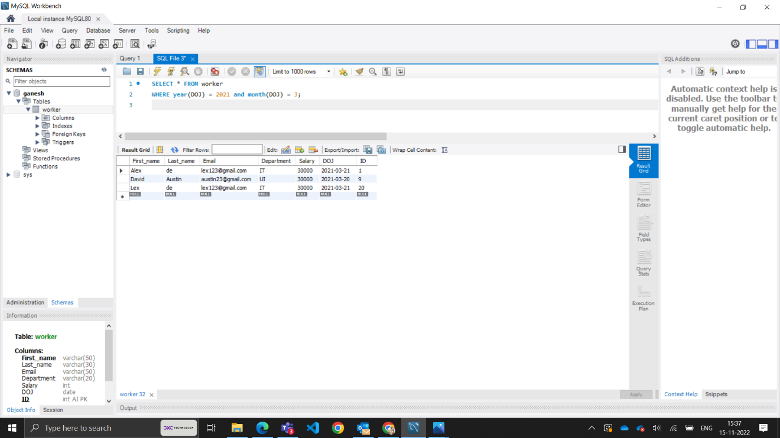

2.Write an SQL query to fetch duplicates that have matching data in some fields of a table.

ANS : SELECT DEPARTMENT, Last_name,COUNT(*) FROM worker GROUP BY Department,Last_name HAVING count(*) > 1;

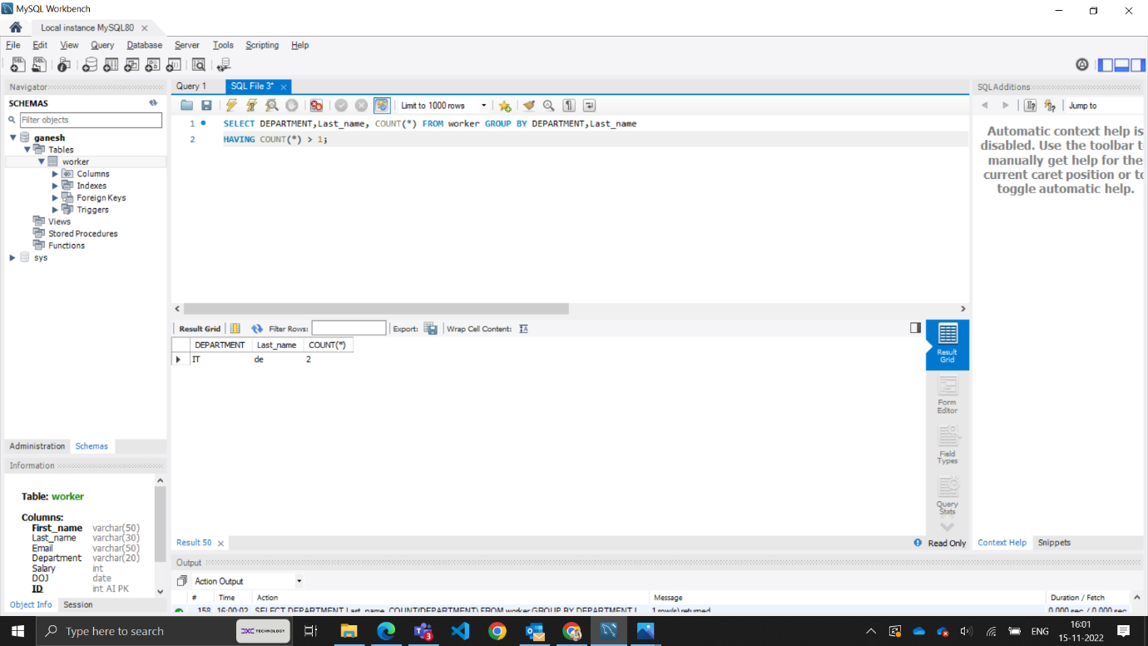

3.How to remove duplicate rows from the Employees table.

ANS : Here you can see the query is executed below in action output.

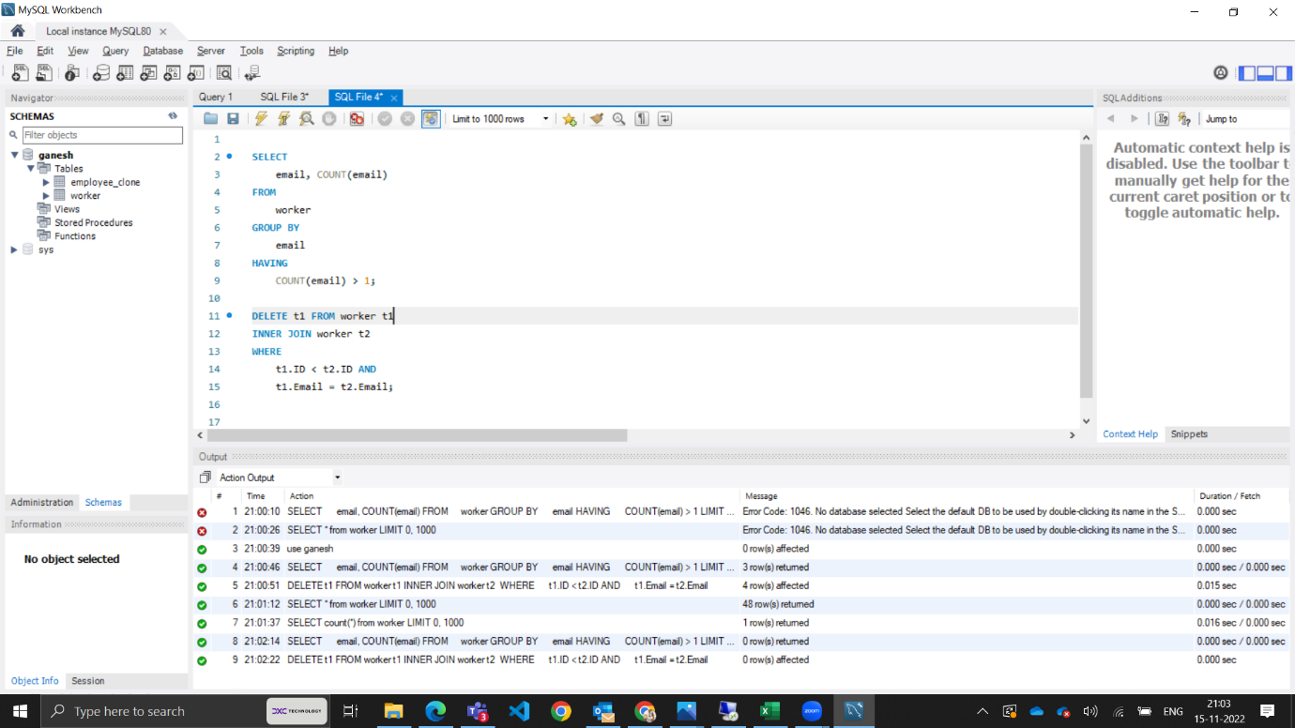

**TASK-7**

1.Write an SQL query to show only odd rows from a table.

ANS : SELECT * FROM worker WHERE MOD (ID,2) <>0;

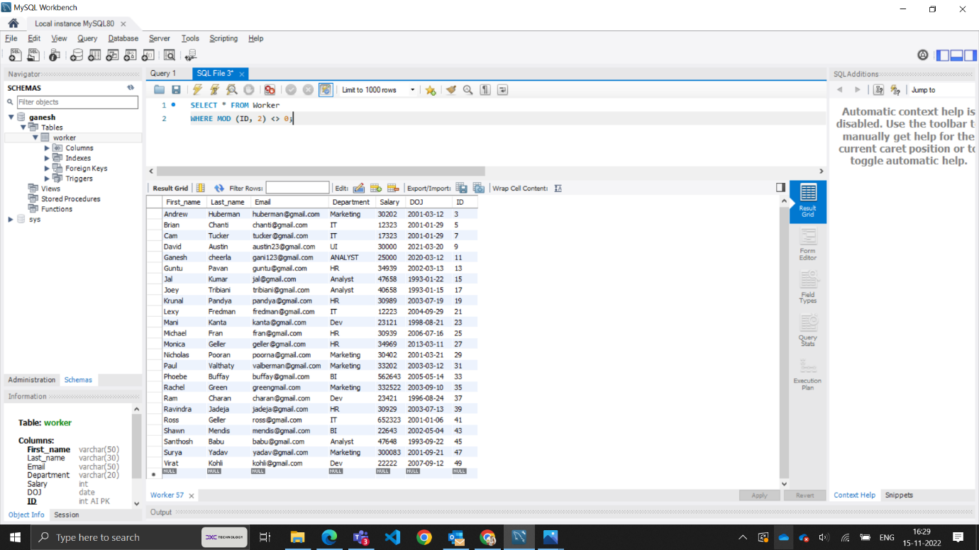

**2.** Write an SQL query to clone a new table from another table.

ANS : CREATE TABLE employee_clone LIKE worker INSERT INTO employee_clone SELECT * FROM worker;

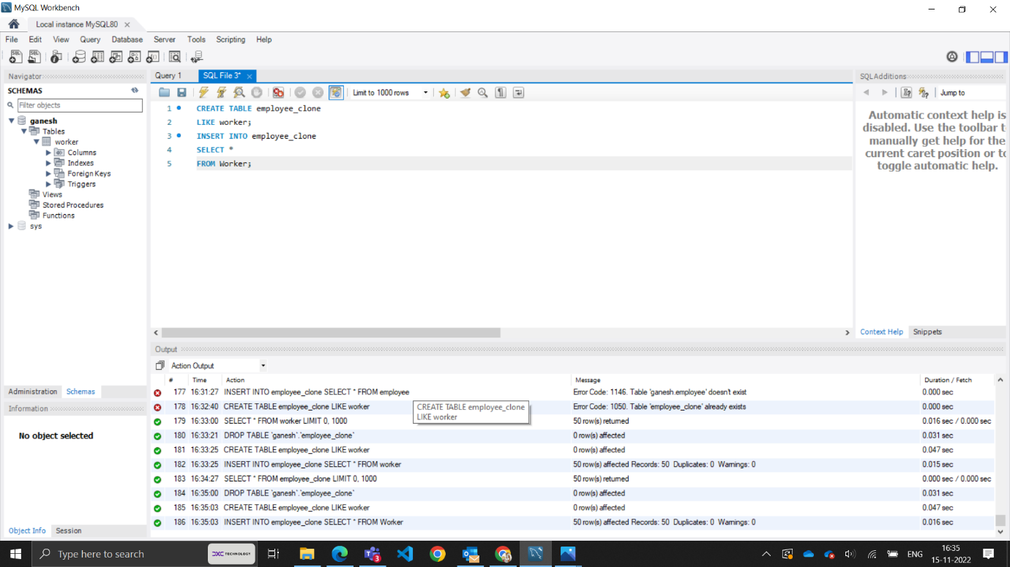

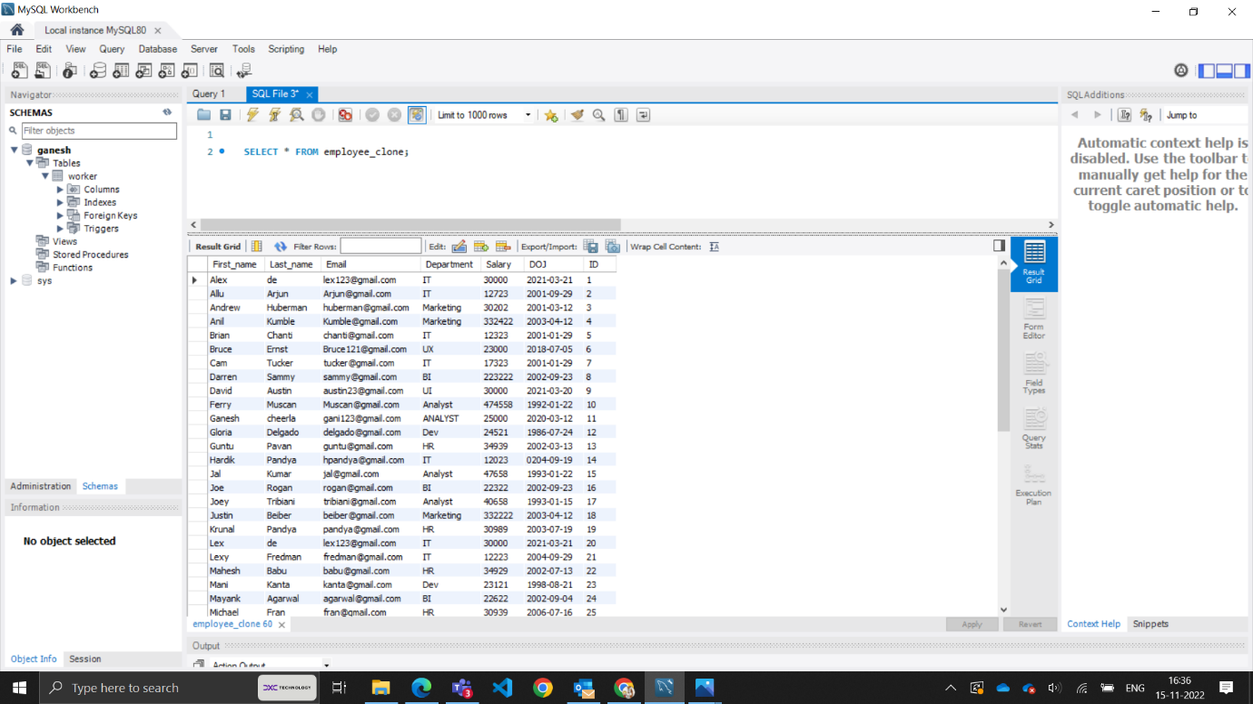

**TASK-8**

1.Write an SQL query to fetch intersecting records of two tables.

ANS : SELECT ID,First_name,Last_name,Email,Department,salary,DOJ FROM worker

WHERE EXISTS(SELECT * FROM employee_clone WHERE worker.First_name = employee_clone.First_name);

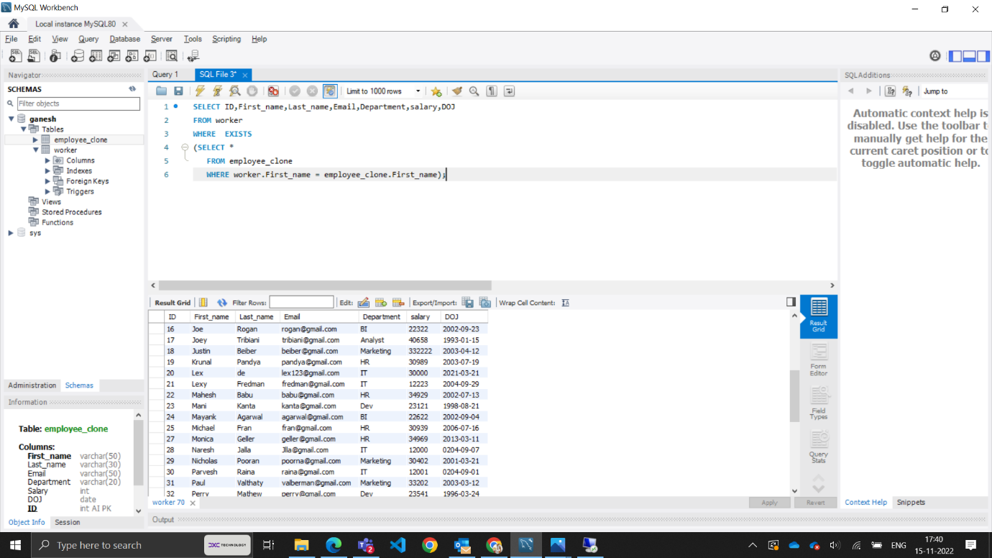

2.Write an SQL query to show records from one table that another table does not have.

ANS : SELECT ID,First_name,Last_name,Email,Department,salary,DOJ FROM worker

WHERE NOT EXISTS(SELECT * FROM employee_clone WHERE worker.First_name = employee_clone.First_name);

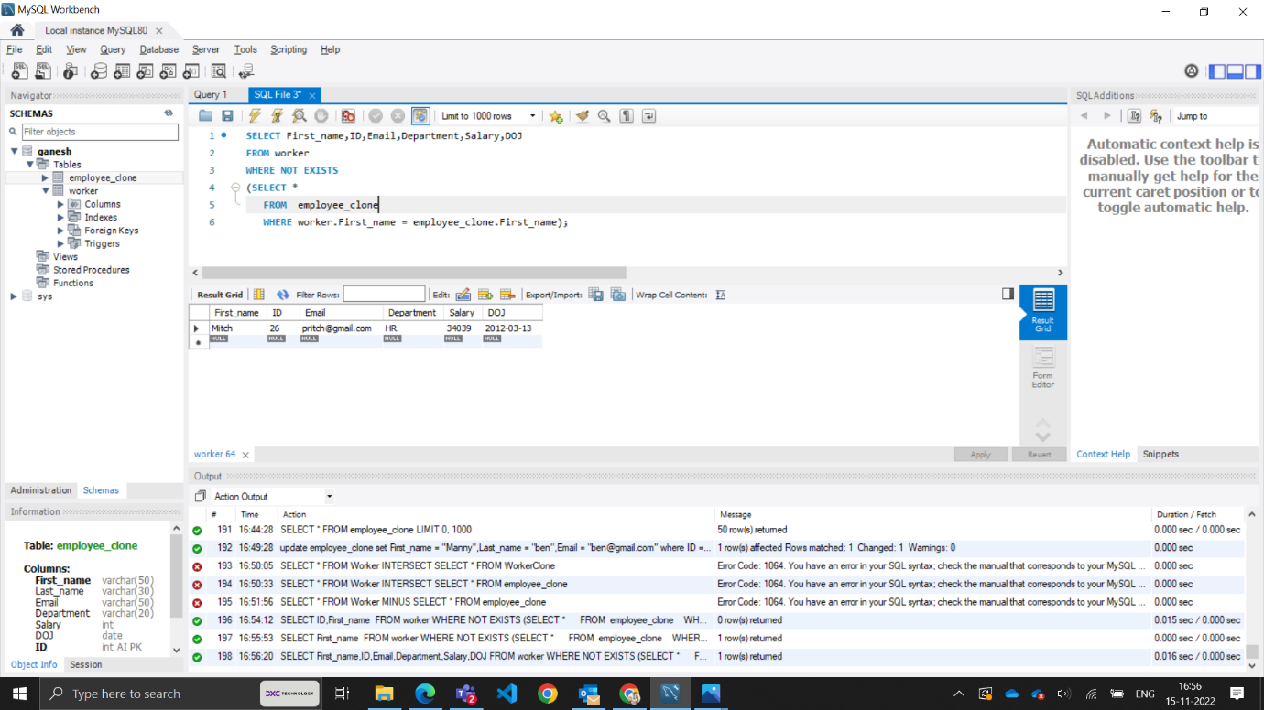

**TASK-9**

1.Write an SQL query to show the top n (say 15) records of a table.

ANS : SLECT * FROM worker ORDER BY Salary DESC LIMIT 10;

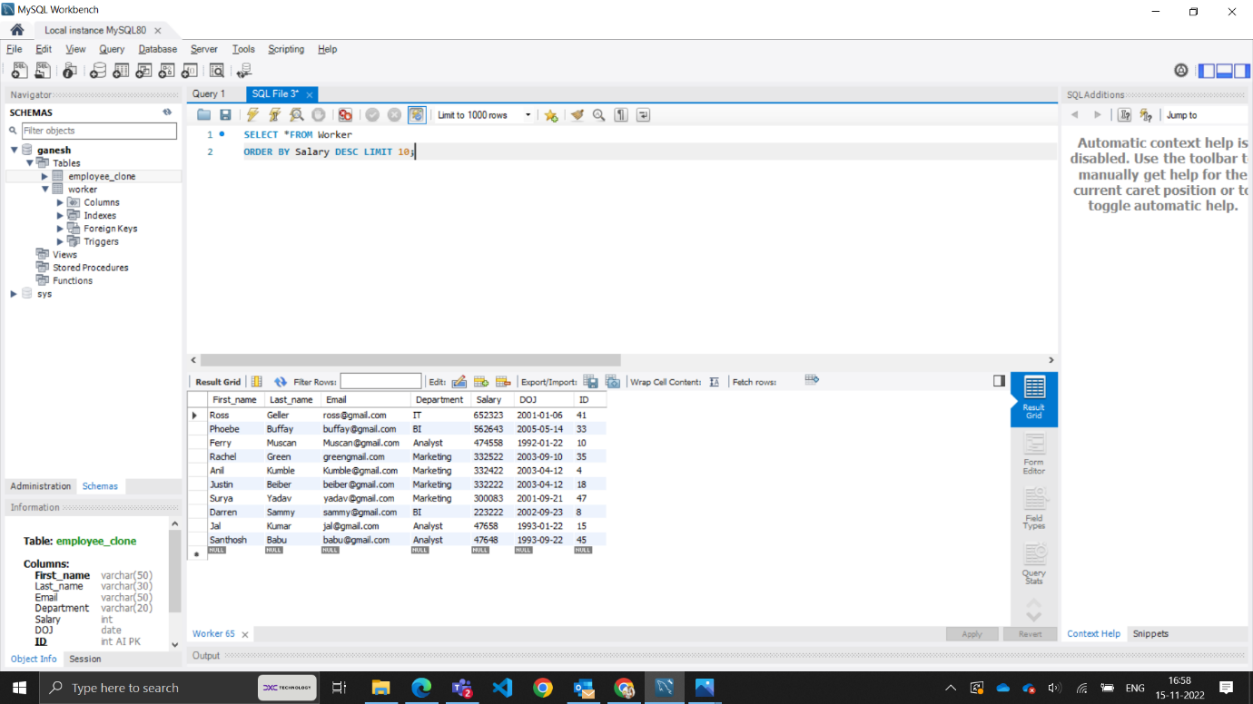

**2.** Write an SQL query to determine the nth (say n=10) highest salary from a table.

SELECT salary from worker ORDER BY salary DESC LIMIT 9, 1;

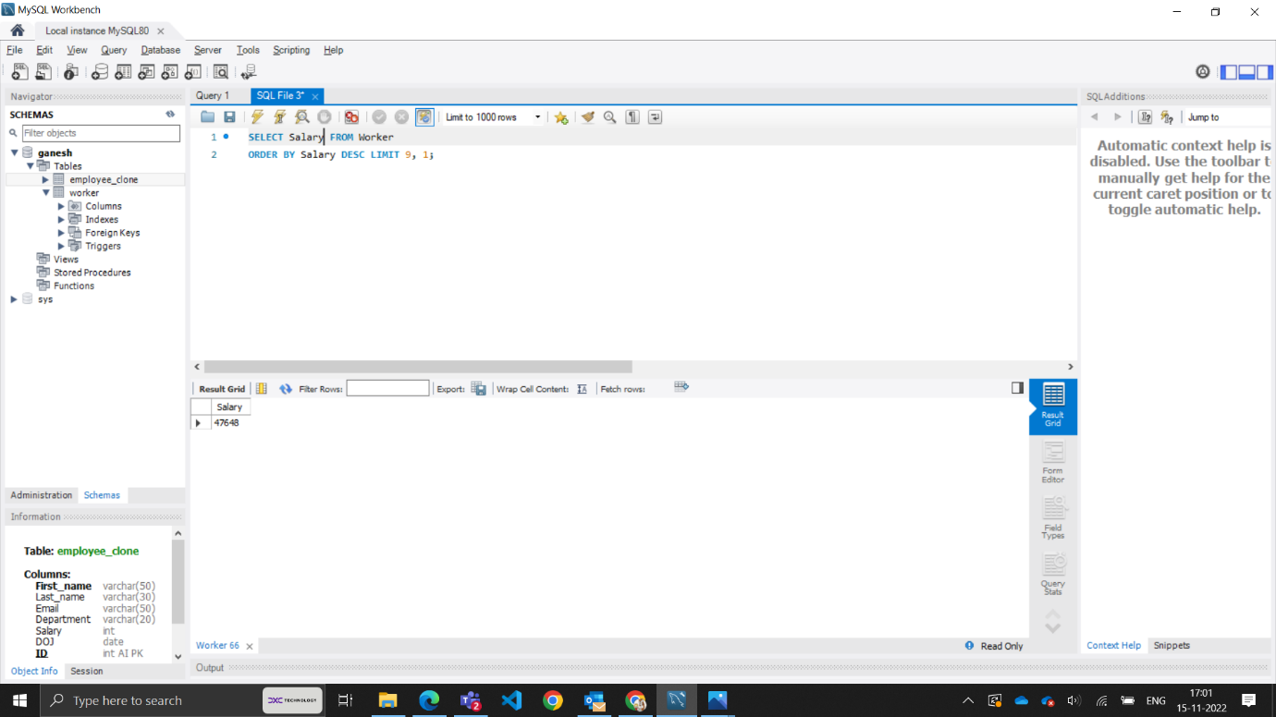

**TASK-10**

1.Write an SQL query to determine the 8th highest salary without using TOP or LIMIT methods.

ANS : SELECT Salary FROM Worker W1 WHERE 7 = (SELECT COUNT( DISTINCT ( W2.Salary ) )FROM Worker W2 WHERE W2.Salary >= W1.Salary );

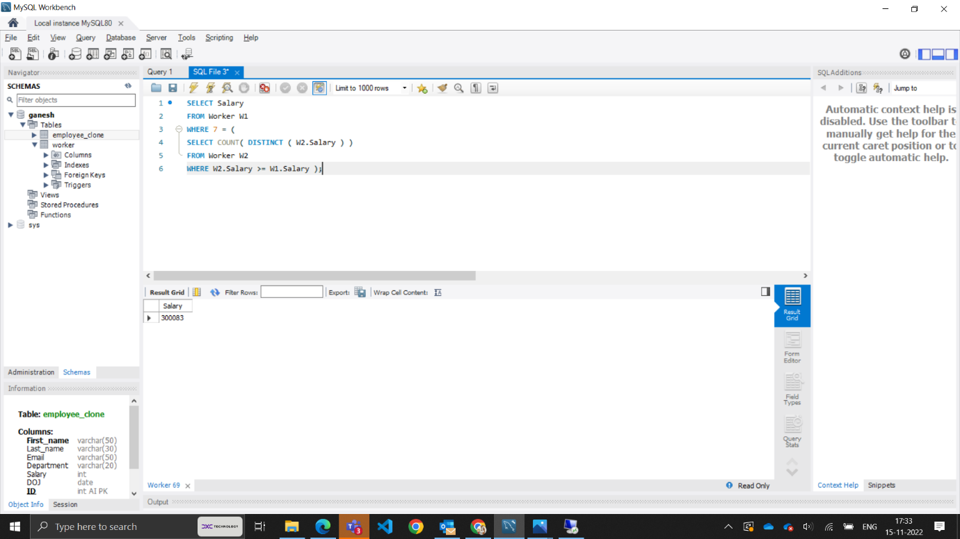

2.Write an SQL query to fetch the list of employees with the same salary.

ANS : Select distinct W.ID, W.First_name, W.Salary from Worker W, Worker W1  
where W.Salary = W1.Salary and W.ID != W1.ID